KINDLY SPONSORED BY ‘THE NORTHERN SNOOKER CENTRE’

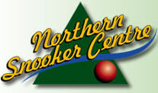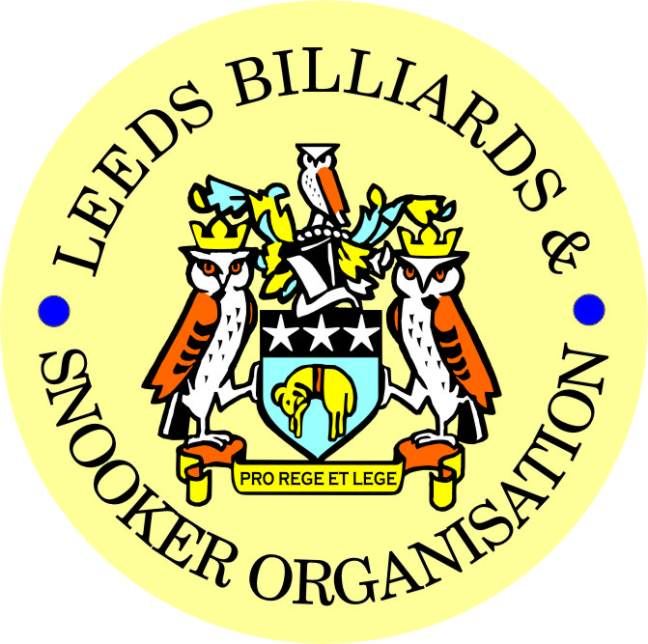

FINAL – 2019 LEEDS CITY SNOOKER CHAMPIONSHIP &
PRIZE PRESENTATION EVENING

FRIDAY 10th MAY 2019 -7-30pm
NORTHERN SNOOKER CENTRE

** 2019 LEEDS CITY CHAMPIONSHIPS **

JUNIORS - UNDER 16’s SNOOKER:
Presented by ADT Flexibles (UK) Ltd.
WINNER: LEWIS HARPER | RUNNER-UP: LIAM PULLEN
SEMI-FINAL: RILEY FISHER | SEMI-FINAL: STANLEY MOODY
JUNIORS - UNDER 18’s SNOOKER:
“The Keith Weston Memorial Trophy”- Presented by ADT Flexibles (UK) Ltd.
WINNER: JOE FENTON | RUNNER-UP: LEWIS HARPER
SEMI-FINAL: SAMUEL LEE STEVENS | SEMI-FINAL: STANLEY MOODY
JUNIOR HIGH BREAK: - “The Paul Hunter Memorial Trophy” – ISA ISHTIAQ (75)

INDIVIDUAL SNOOKER:
WINNER: LEWIS GILLEN | RUNNER-UP: LEWIS HARPER
SEMI-FINAL: SCOTT RAPER | SEMI-FINAL: LIAM PULLEN
PAIRS SNOOKER:
Trophy - Presented by ADT Flexibles (UK) Ltd.
WINNERS: J BAGLEY / D WOMERSLEY | RUNNERS-UP: D MYERS / A RENNISON
TEAM SNOOKER – “The Jim Fowler’s Trophy”:
WINNERS: GILDERSOME CONS | RUNNERS-UP: HORSFORTH CONS

2018-2019 - *PRIZE PRESENTATION EVENING*

WEDNESDAY 17th JULY 2019 – from 7-00pm

HOLBECK WMC

SNOOKER - “Veterans Trophy”  “The Rodney Sims Memorial Trophy”  Trophy presented by the LBSO | REFEREES:  Officiated in 2018-19 LBSO Competitions:
WINNER: PAUL GRIMES | ALEX CRUM
RUNNER-UP: PETER NEVILLE | MICHAEL DAVENPORT
 | KENNETH SYMONS
PLATE WINNER: DAVE HORRY | MARK KING
PLATE RUNNER-UP: ALAN HARDING

** LBSO - BILLIARDS & SNOOKER LEAGUES **

Div: | CUP TITLE / WINNERS: | RUNNERS-UP:
Div A | The Yorkshire Evening News Shield:  EXCELSIOR S.C. ‘A’ | HAREHILLS WMC ‘A’
Div B | The Clan Tartan Trophy:  TINSHILL & COOKRIDGE ‘A’ | EAST END PARK ‘B’
Div C | The John Dunning Trophy:  BRAMLEY VILLAGERS ‘A’ | MORLEY INTERNATIONAL
Div D | The J. H. Lunn Cup:  HAREHILLS LABOUR ‘A’ | THE NEW MIDDLETON CLUB
Div E | The Peter Nelson Trophy:  HORSFORTH CONS | MIDDLETON CONS ‘B’
Div F | The Peter Hawkyard Memorial Trophy:  BELLE ISLE WMC ‘D’ | ROWLAND ROAD ‘B’
Div G | The J. McDonnell / J. Williamson Trophy:  NEW WORTLEY LABOUR ‘B’ | EAST LEEDS SNOOKER CENTRE

“CHAMPION of CHAMPIONS”  “The Jim Williamson Memorial Trophy”  Presented by the Northern Snooker Centre | WINNERS: HAREHILLS LABOUR ‘A’  (DIVISION D WINNERS)

LBSO LEAGUE & COMPETITIONS – SNOOKER HIGHEST BREAKS
HIGHEST BREAK TROPHY
Presented by ADT Flexibles (UK) Ltd. in 2019
Break | League / Competition | Player (Team)
137 | LEN LEE PAIRS | RICHARD BINNS (BELLE ISLE WMC ‘B’)
124 | LEN LEE INVITATION | DAVE BARKER (MAIN LINE SOCIAL ‘A’)
103 | LEEDS CITY SNOOKER IND | DEAN PATTISON (BELLE ISLE WMC ‘D’)
101 | LEAGUE / DIVISION ‘F’ | STEVE MOODY (MORLEY CONS ‘B’)
100 | LEEDS CITY SNOOKER TEAM | SCOTT RAPER (HORSFORTH CONS)
98 | LEN LEE INVITATION | LIAM BARLOW (EXCELSIOR SC ‘A’)
88 | LEAGUE / DIVISION ‘A’ | RYAN WALTON (EXCELSIOR SC ‘A’)
55 | LEAGUE / DIVISION ‘D’ | DARREN BELL (SWILLINGTON MW)

LEN LEE INVITATION SNOOKER – (Scratch):  “THE LEN LEE TROPHY” | WINNER: RICHARD BINNS (BELLE ISLE WMC)  RUNNER-UP: LIAM BARLOW (DENISON HALL)  SEMI-FINAL: ANTHONY SUMNER (HAREHILLS WMC)  SEMI-FINAL: CHRIS HART (NEW HEADINGLEY)

SNOOKER – Individual Handicap.
The “GEORGE SYKES CUP”

WINNER: ADAM RENNISON  (HAREHILLS LABOUR) | RUNNER-UP: BRIAN HUSSEY  (DENSION HALL CLUB)
SEMI-FINAL: JORDAN WILKINSON  (SEACROFT WMC) | SEMI FINAL: GERRY WALTON  (DENSION HALL CLUB)

SNOOKER – Pairs Handicap.
The “LEN LEE CUP”

WINNERS: G. GODFREY & V. ROY  (NORTHERN S.C.) | RUNNERS-UP: S.HIRST & D.PATTISON  (BELLE ISLE WMC)
SEMI-FINAL: G.STEAD & G.WALTON  (DENISON HALL CLUB) | SEMI-FINAL: P.BUCKLE & S.QUIGLEY  (NEW MIDDLETON CLUB)

SNOOKER - 3 MAN TEAM KNOCK OUT – Handicap.
The “Leeds & District Billiards League Snooker Cup”

WINNERS: HORSFORTH CONS | RUNNERS-UP: GARFORTH WMC
SEMI-FINAL: BRAMLEY BAND CLUB | SEMI FINAL: U & L WORTLEY LIBERALS

** STAN BROOKE MEMORIAL COMPETITIONS **
(AGGREGATE SCORES – 3/4 FRAMES)

INDIVIDUAL SNOOKER – 3 FRAMES:

WINNER: RYAN MASSEY  (HAREHILLS WMC) | RUNNER-UP: TONY BARKER  (DENISON HALL CLUB)
SEMI-FINAL: KEN McKAY  (DENISON HALL CLUB) | SEMI FINAL: JAMES PEARS  (BARNBOW SOCIAL CLUB)
PAIRS SNOOKER – 3 FRAMES:

WINNERS: J.SHAW & M.GOLDEN  (TINSHILL & COOKRIDGE) | RUNNER-UP: D.GRIMES & A. TAFFINDER  (MORLEY WMC)
SEMI-FINAL: D.BOOTH & P.WHITTAKER  (BELLE ISLE WMC) | SEMI-FINAL G.TAYLOR & N. WHITTAKER  (HORSFORTH CONS)
TEAM SNOOKER – 4 FRAMES:

WINNERS: BELLE ISLE WMC ‘B’ | RUNNERS-UP: NEW MIDDLETON CUB
SEMI-FINAL: BELLE ISLE WMC ‘D’ | SEMI-FINAL: PUDSEY LIBERAL CLUB

The “WINDSOR TROPHY” – 4 Man Team Handicap
Presented by ADT Flexibles (UK) Ltd.

WINNERS: BELLE ISLE WMC | RUNNERS-UP: MAIN LINE SOCIAL CLUB
SEMI-FINAL: HAREHILLS WMC | SEMI FINAL: CHAPEL ALLERTON CLUB

CONGRATULATIONS!
TO ALL PRIZE WINNERS FOR 2018-19
The LBSO would like to thank
- the Northern Snooker Centre for staging the final of the Leeds City Singles Championship and the 1st presentation of all 2018 Leeds City Champions on 10th May, and
- Holbeck WMC for staging tonight’s 2nd presentation of this season.
Annual General Meeting - AGM.
MONDAY 2nd SEPTEMBER 2019 – 7-45pm
at
HOLBECK WMC

CURRENT LBSO COMMITTEE MEMBERS
PRESIDENT – CHRIS WILLIAMSON
CHAIRMAN – ANDY TAFFINDER
VICE CHAIRMAN –
LEAGUE SECRETARY – PAUL GRIMES
COMPETITION SECRETARIES – MARK BALL & PAUL MARLOW
GENERAL SECRETARY / TREASURER – BOB PATTERSON

The LBSO would also like to thank the Committee and Members of Holbeck WMC, for allowing us the use of the club for LBSO delegate meetings and AGM, this season and in the past.

OTHER DATES FOR YOUR DIARY:
2nd September 2019 - Scorebook Collection (ALSO AGM), &
4th September 2019 – START OF THE 2019/20 LEAGUE SEASON

Produced By
Kindly Sponsored by the ‘NORTHERN SNOOKER CENTRE’

